**INDUSTRY INTERNSHIP REPORT**

On

# “Web Development”



**By**

**SHAIK MOHAMMED AMAAN (219X1A05H1)**

*Submitted in accordance with the requirement for the degree of B-Tech*

*in*

**Department of Computer Science and Engineering**

**G. PULLA REDDY ENGINEERING COLLEGE (Autonomous): KURNOOL**

**(Affiliated to JNTUA, ANANTHAPURAMU)**

**KURNOOL - 518007**

## 2024 – 2025

**Department of Computer Science and Engineering**

**G. PULLA REDDY ENGINEERING COLLEGE (Autonomous): KURNOOL**

**(Affiliated to JNTUA, ANANTHAPURAMU)**



**CERTIFICATE**

***This is to certify that the internship titled*** ‘Web Development’ **is a bonafide record of work carried out by SHAIK MOHAMMED AMAAN (219X1A05H1), and the Internship report is submitted in partial fulfillment of requirements for the award of degree of Bachelor of Technology in Computer Science and Engineering.**

**……………………………..**

Internship Guide

**Dr. S. Zahoor-ul-huq**

Professor

Department of C.S.E., G. Pulla Reddy Engineering College,

Kurnool.

**……………………………..**

**HEAD OF THE DEPARTMENT**

**Dr. N. Kasiviswanath**

Professor & Head of the Department,

Department of C.S.E., G. Pulla Reddy Engineering College, Kurnool.

**INTERNSHIP DETAILS**

**Name of the College**: G. Pulla Reddy Engineering College

**Department**: Computer Science and Engineering

**Name of the Student**: Shaik Mohammed Amaan

**Register Number**: 219X1A05H1

**Name of the Faculty Guide**: Dr. S. Zahoor-ul-huq

**Duration of the Internship**: From 06-01-2025 To 28-04-2025

**Name and address of the Organization**: Modern MonkLabs, Eden Gardens, Road No. 10, Banjara Hills, Hyderabad.

**Internship Domain**: Web Development

**Internship Title**: Learning Management System

**Internship Stipend**: N/A

**Date of Internship Report Submission**:

**Internship Coordinator**

**Dr.B.Geetha Vani**

**Professor**

**CSE Department**

**GPREC**

### DECLARATION

I **Shaik Mohammed Amaan**, a student bearing the Roll No. **219X1A05H1**, of the Department of Computer Science and Engineering, G. Pulla Reddy Engineering College, do hereby declare that the I have completed the mandatory internship titled **Learning Management System** from **06-01-2025** to **28-04-2025** in **Modern MonkLabs**, **Hyderabad** under the Faculty Guide ship of **Dr. S. Zahoor-ul-huq, Professor**, Department of C.S.E., G. Pulla Reddy Engineering College, Kurnool.

***(Student Signature and Date)***

## Certificate from Organization

This is to certify that **Shaik Mohammed Amaan**, Reg No. **219X1A05H1** of **G. Pulla Reddy Engineering College**, **Kurnool**, underwent Internship in **Modern MonkLabs** from **06-01-2025** to **28-04-2025**.

The overall performance of the Intern during his/her internship is found to be **Good.**



**Internship completion certificate**

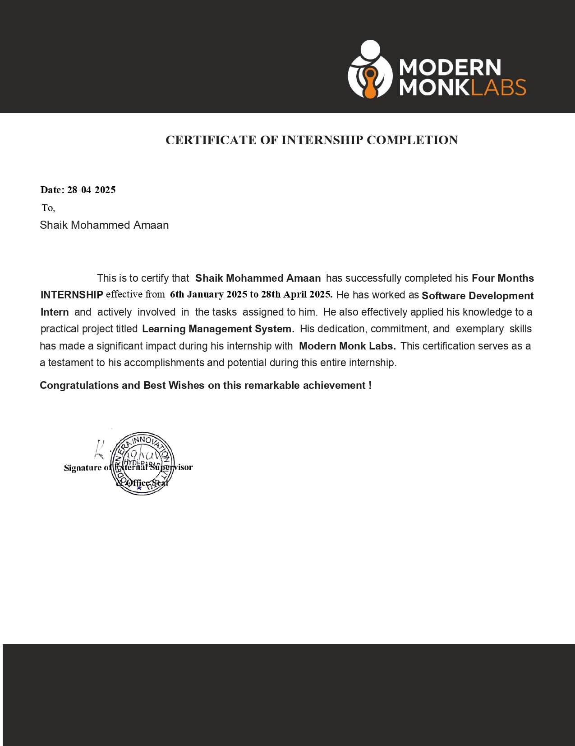

### ACKNOWLEDGEMENT

I wish to express my deep sense of gratitude to my internal supervisor **Dr. S. Zahoor-ul-huq**, **Professor** of Computer Science and Engineering Department, G. Pulla Reddy Engineering College.

My sincere thanks to our Internship Coordinator **Dr.B.GeethaVani** for her immaculate guidance, constant encouragement and cooperation which have made possible to bring out this internship work.

My sincere thanks to **Mr.** **Raghava Kalva**, **CEO** of **Modern MonkLabs**, for helping me and giving me the required information needed for my internship work.

I am thankful to our Head of the Department **Dr.N.Kasiviswanath**, for his wholehearted support and encouragement during the internship.

We are grateful to our Internship Dean **Dr.Y.V.Siva Reddy** and to our respected Principal **Dr.B.Sreenivasa Reddy** for providing requisite facilities and helping us in providing such a good environment.

I wish to convey my acknowledgements to all the staff members of the Computer Science and Engineering Department for giving the required information needed for my internship work.

Finally, I wish to thank all our friends and well wishers who have helped me directly or indirectly during the course of this internship work.

**Table of Contents**

Page No

**Chapter 1**: **INTRODUCTION**..............................................................................**1**

1.1 About the Internship Company/Organization......................................2

1.2 Virtual/Offline Internship details.........................................................3

**Chapter 2**: **WORK DONE DURING INTERNSHIP.**........................................6

2.1 About Course/Domain………………………………………………7

2.2 Technologies learnt during internship……………………………….9

2.3 Assessments/Tasks assigned details………………………………..10

**Chapter 3**: **PROJECTS/MODULES COMPLETED**.......................................13

3.1 About Module 1…………………………………………………….14

3.2 About Module 2…………………………………………………….16

3.3 About Module 3…………………………………………………….18

3.4 About Module 4…………………………………………………….20

3.5 About Module 5…………………………………………………….22

3.6 About Module 6…………………………………………………….24

3.7 About Project 1……………………………………………………..26

**Chapter 4**: **ACTIVITY LOG** ............................................................................48

**Chapter 5**: **CONCLUSION** ...............................................................................52 **References** ...............................................................................................54

**LIST OF FIGURES**

|  |  |  |
| --- | --- | --- |
| **FIGURE NO.** | **FIGURE NAME** | **PAGE NO.** |
| 1.2.1 | Internship at The Web Blinders | 4 |
| 2.1.1 | Life Cycle of Web Development | 7 |
| 3.7.1 | Home Page and About us Page Design | 33 |
| 3.7.2 | Sign up/Sign in page and Course List Page | 34 |
| 3.7.3 | Course Content Page Design | 34 |
| 3.7.4 | User Dashboard Page and Checkout Page Design | 35 |
| 3.7.5 | Design Prototype | 35 |
| 3.7.6 | Home Page | 37 |
| 3.7.7 | Course Section | 38 |
| 3.7.8 | Testimonials | 38 |
| 3.7.9 | Features | 39 |
| 3.7.10 | Sign up Page | 40 |
| 3.7.11 | Sign in page | 40 |
| 3.7.12 | About us Page | 41 |
| 3.7.13 | Course list page | 43 |
| 3.7.14 | Search Functionality | 43 |
| 3.7.15 | Course Enrollment Page | 44 |
| 3.7.16 | Course Media Page | 44 |